CSE 581

**Lab 14: Cursors**

**Purpose:**

Create a function with a **cursor**.

**Deliverables:**

Multiple screenshots, as described through the lab.

Scripts that you used to carry out the actions.

**Steps:**

1. Create a function which will walk through the Enrollment table and calculate the average grades for each of the students[1]. Provide a **screenshot** of script execution. *The function will take in a student id as a parameter and then calculate that student’s average grade (round to hundredth).*

1. Execute the function. Provide a **screenshot** of execution, showing the results. Also provide a **screenshot** of the data, proving that your function worked as expected (please write a single SELECT statement that will provide the answers).

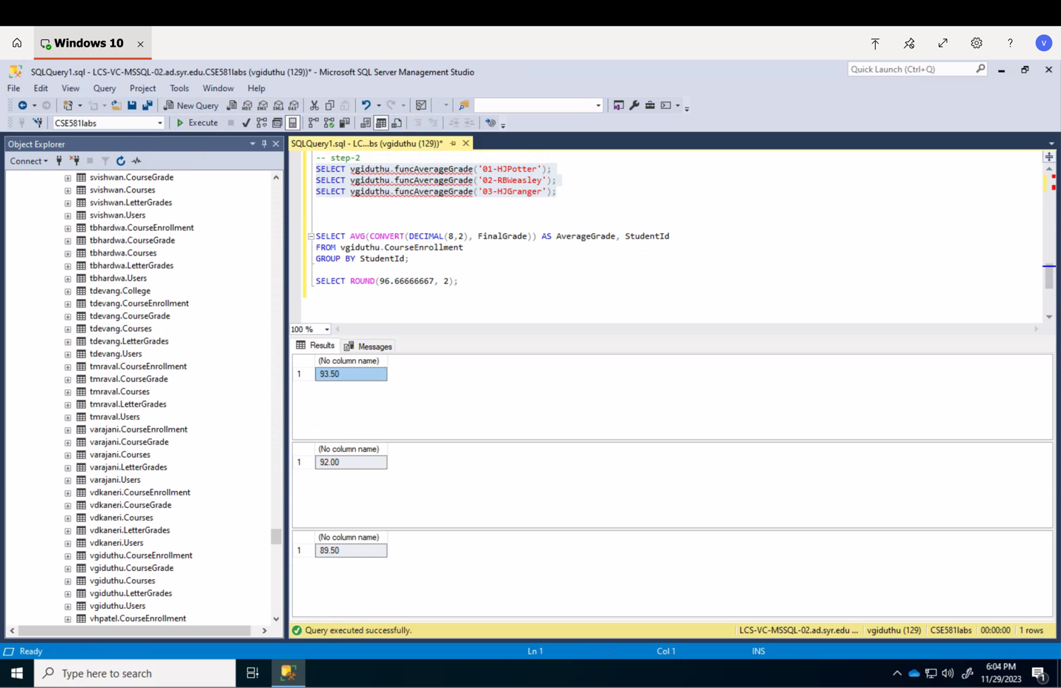

1. Please note that this can be done in easier ways, but the point here is to create a cursor and make sure it works.